ABOUT ME!

Name: Francesca Carino

* Second year computer science major
* Interest began doing block coding in elementary
  + Participated in a game jam
* Unity experience in high school (clicker, space shooter, 2d RPG 2d/3d platformer)
* Favourite video games: Stardew Valley, Hades, Ori Duology, Tetris

DRESS TO IMPRESS WORKSHOP

**Day 1 – Unity Setup and Poses**

1. Download [Unity](https://unity.com/download) (version 2022.3.55f1)
2. Create new project and load DTI Workshop Template Package
   1. Add additional required packages - Window > Package Manager > Unity Registry (Input System & Cinemachine)
3. Select 3 animations from options provided
4. Introduce animator controller
   1. Transitions
   2. Triggers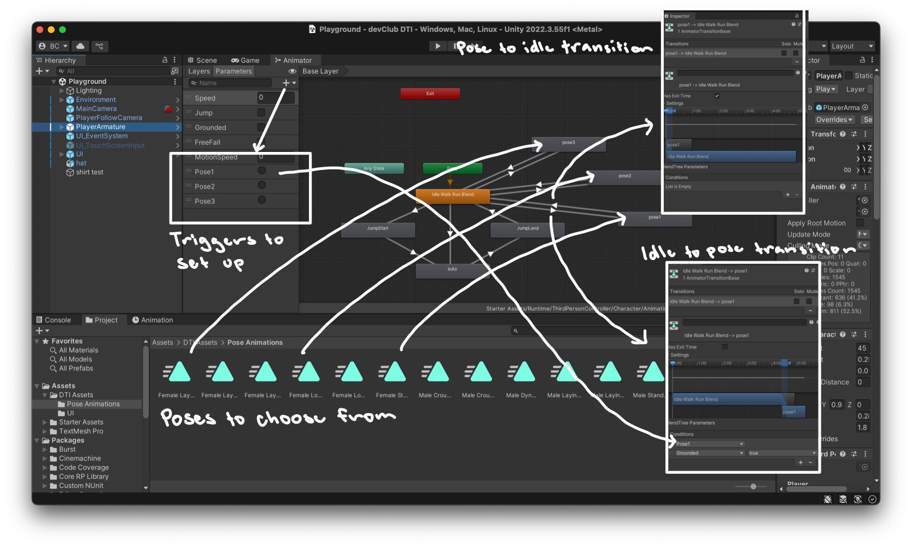
5. Code button functions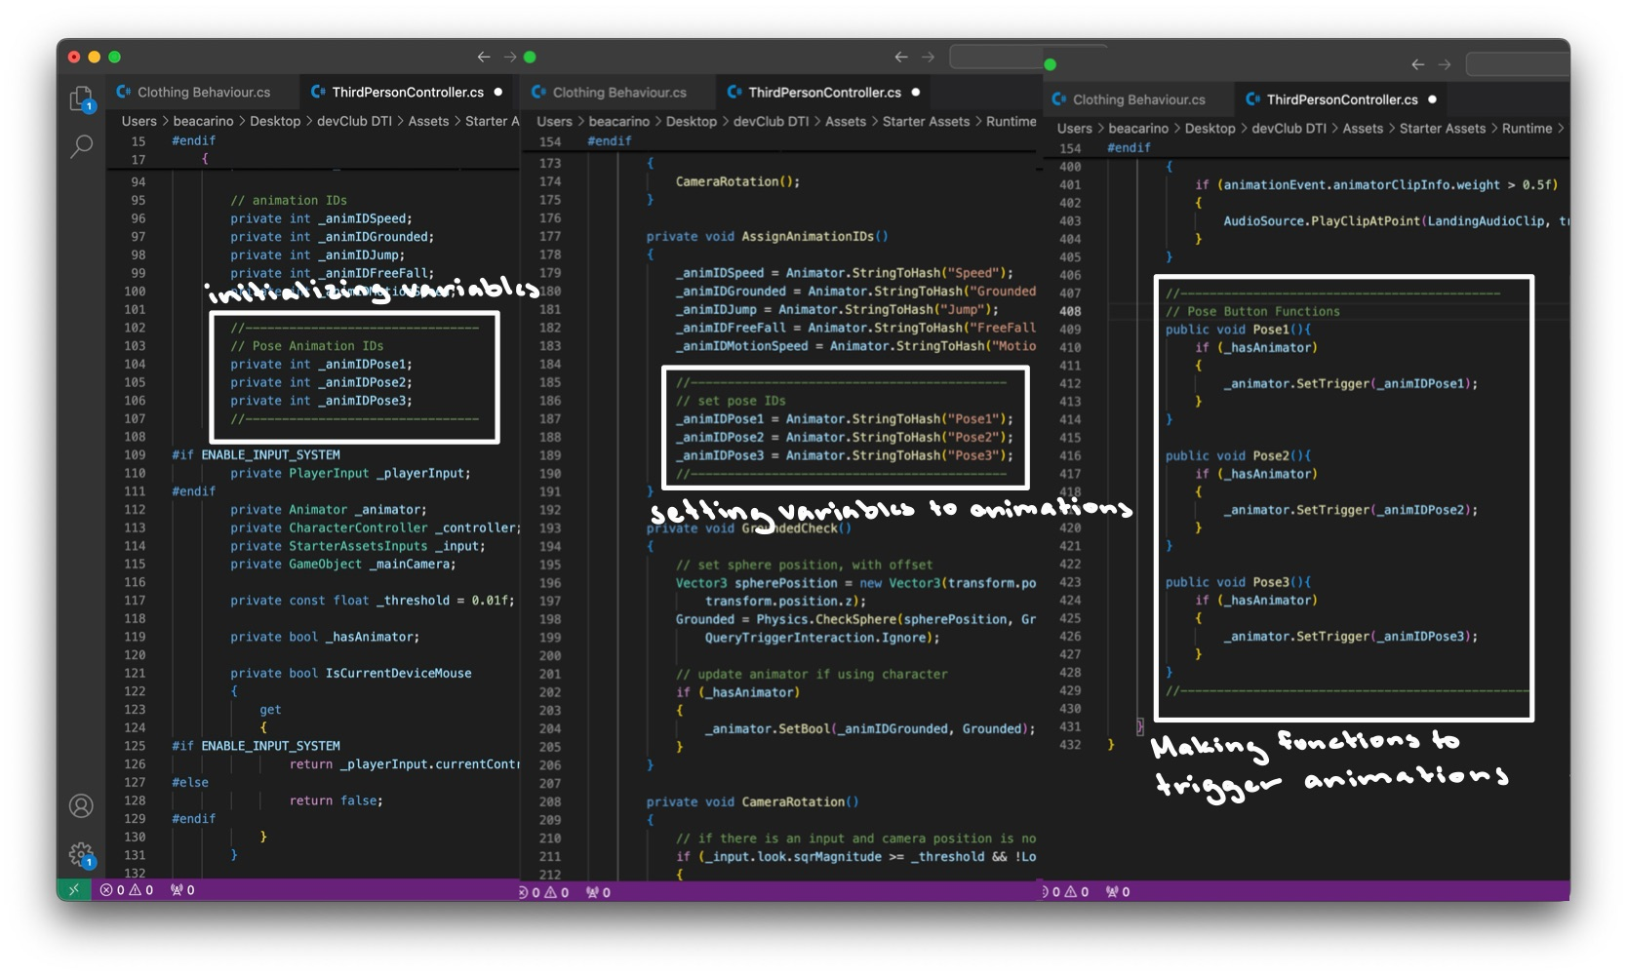
6. Connect functions to UI buttons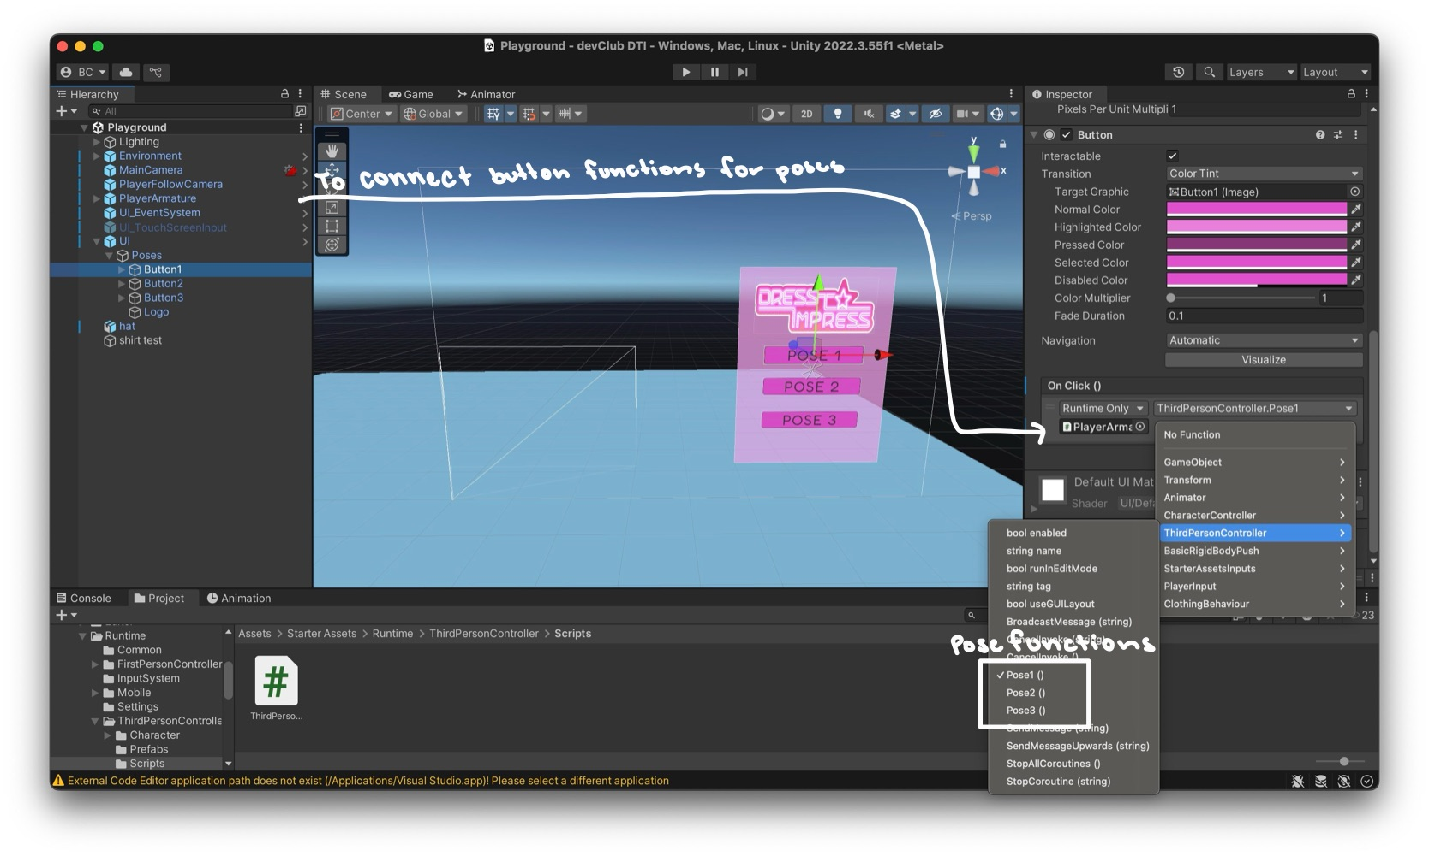

**Day 2 – Clothes on Player**

1. Code clothing behaviour script
   1. Basics – tag checking, object getting, vector positions
   2. Ray casting – mouse tracking and clicking
   3. Coroutines – ienumerators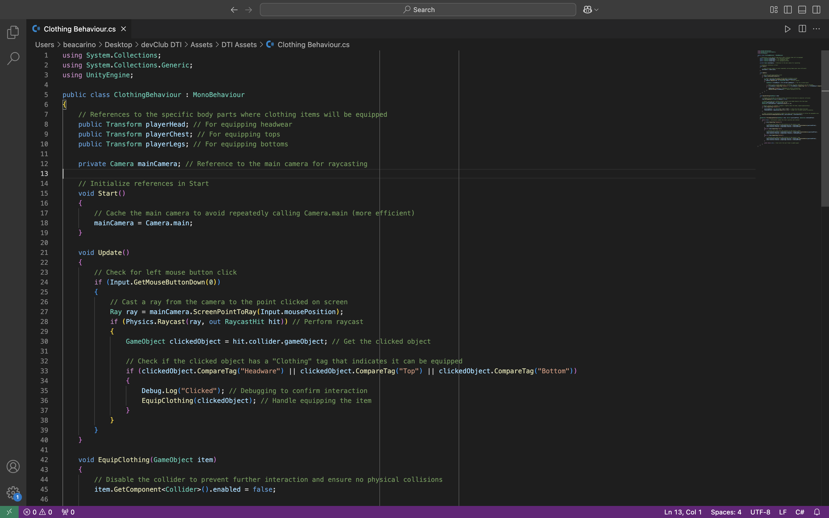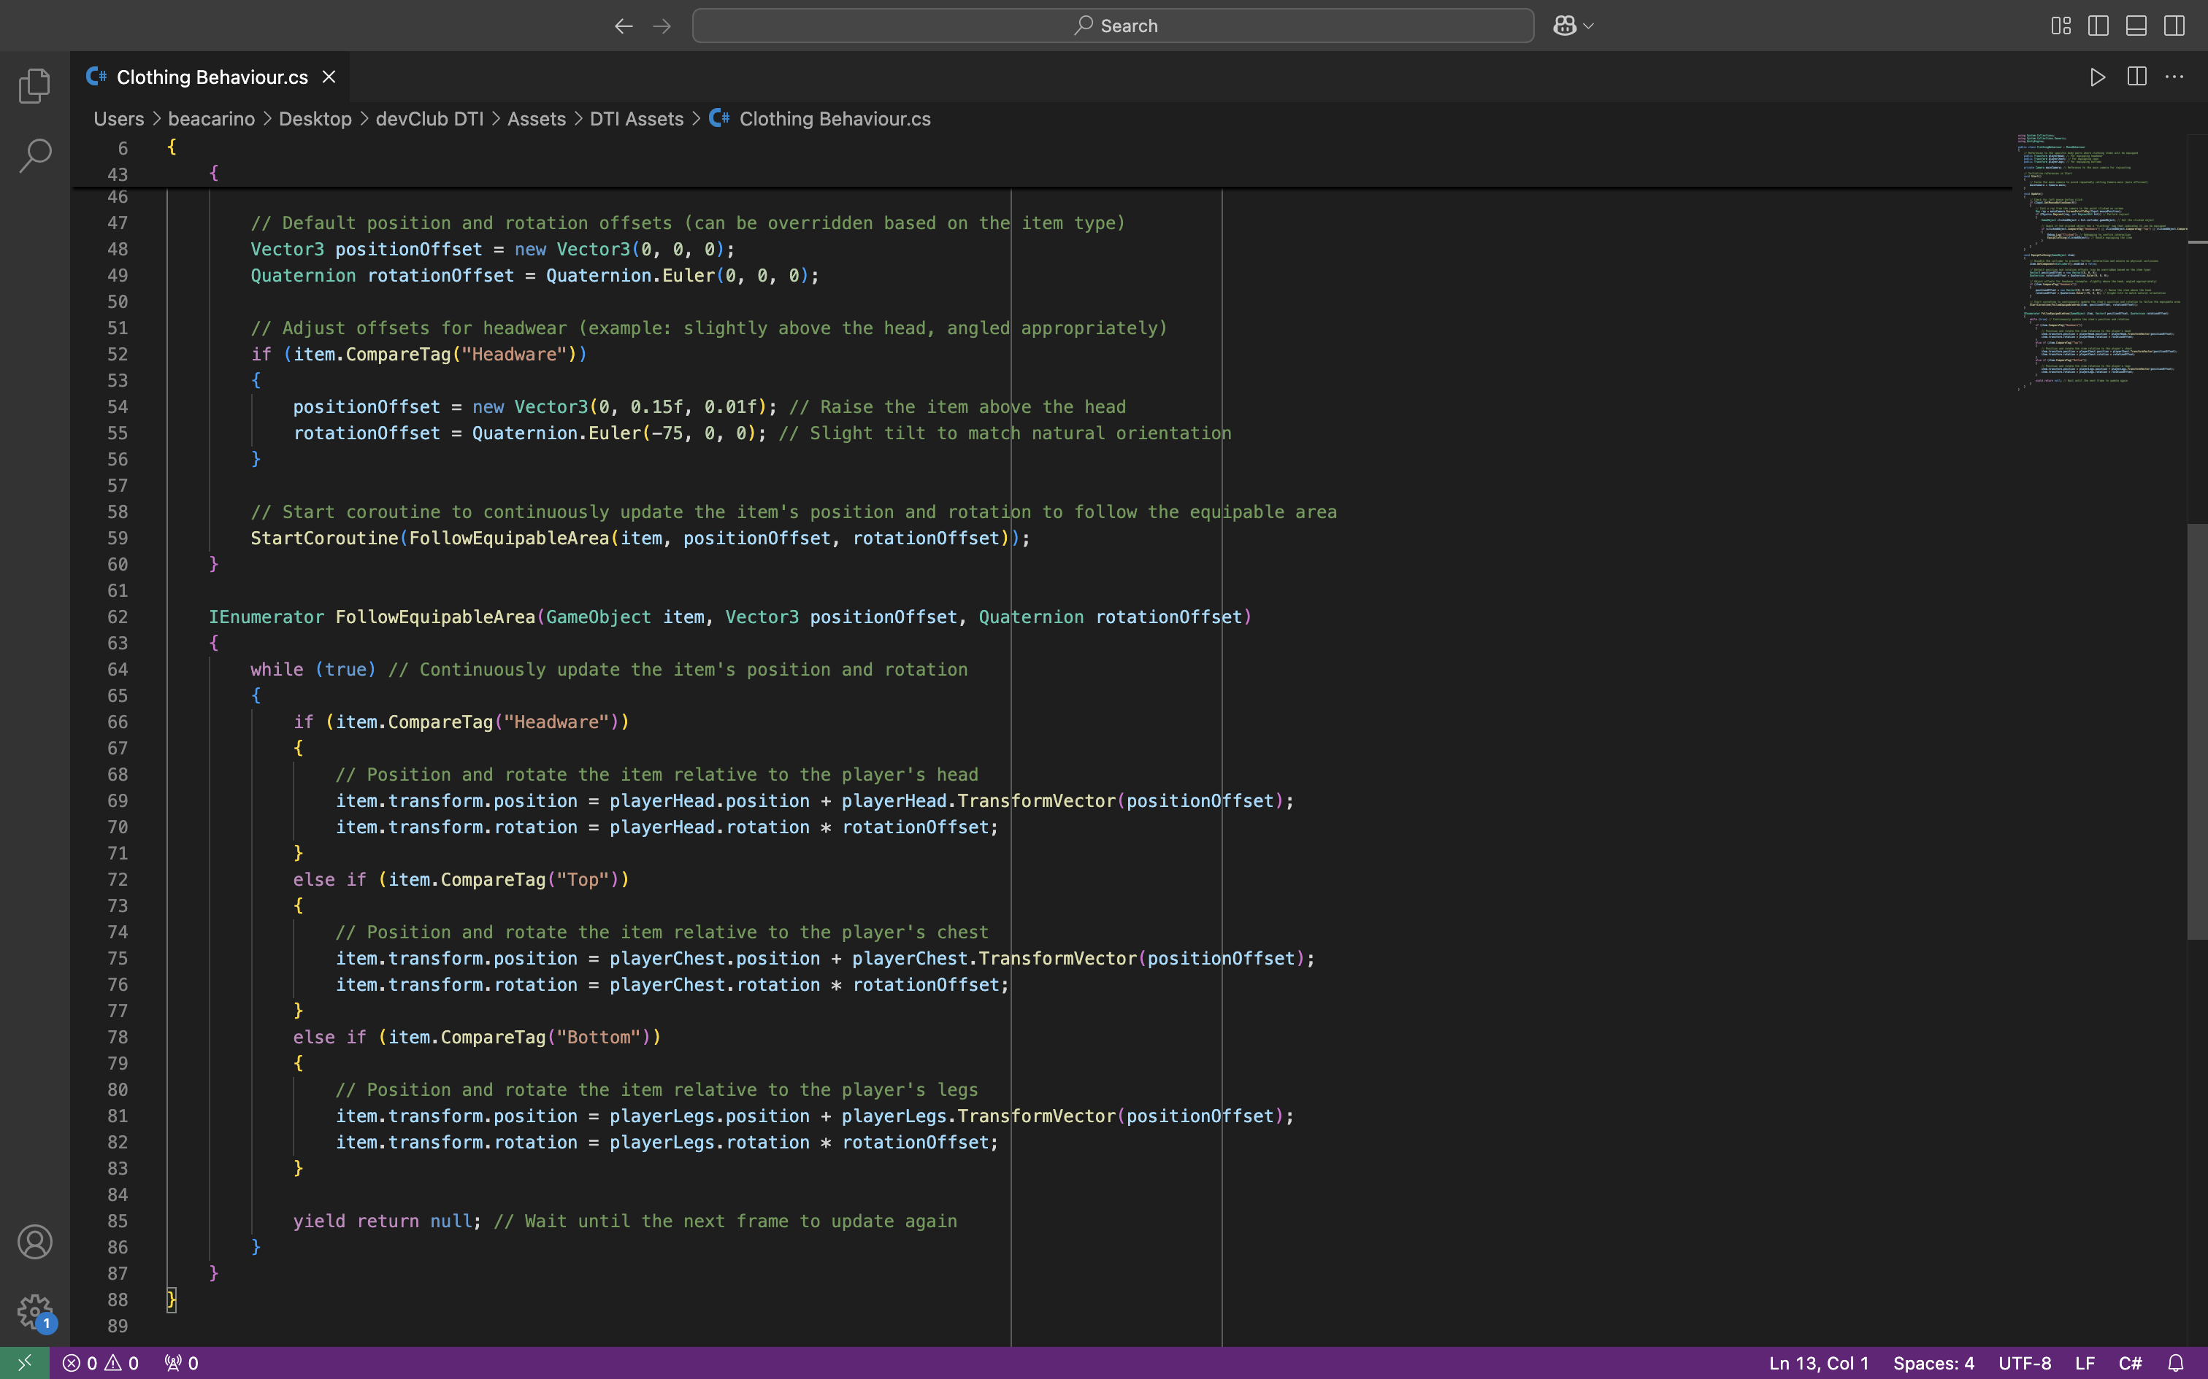
2. Ensure clothes have correct setting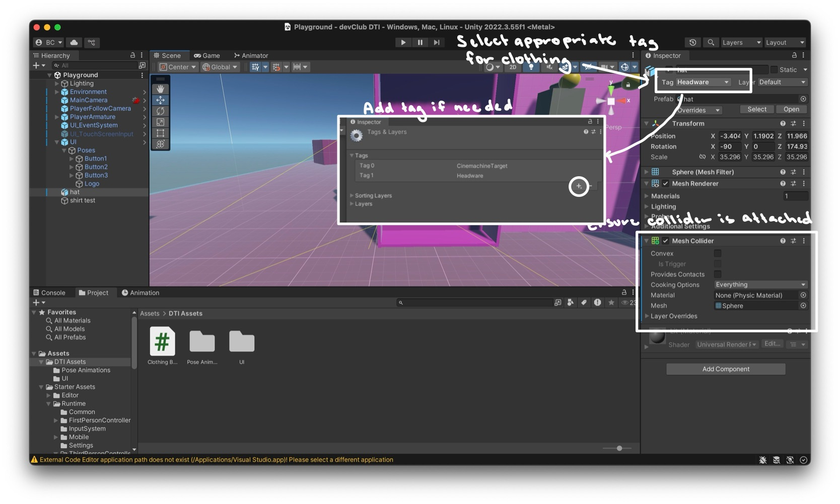s
3. Attach behaviour to player